**Google Cloud Setup**

**Register on Google Cloud Platform**

First of all, you have to register on Google cloud. It’s easy. Just sign-in with your Gmail id and fill your credit card details. They will charge somewhat around 50 INR, which is refundable. Once registered you will get (300 USD) 1-year free subscription on Google Cloud.

**How to create Virtual Machines**

* Create a **new project**. Give a name to your project or leave as it is provided by Google.
* Now click on the icon on the top left corner of your home page. A list of products and services will appear which the Google cloud provides. Click on **Compute Engine** and then click on **VM instances.**The VM Instances page will open, select **Create Instance.**

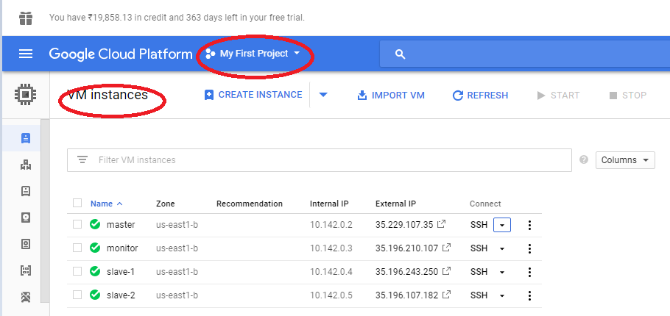

* Now you have to set up the instance.

1. **Name** – Give a name to your VM Instance.
2. **Zone** – Select any zone from the drop down list.
3. **Machine Type** – 1vCPU and you can increase your memory size up to 6.5 GB using customize option.
4. **Boot disk** – Click on change. I am familiar with Red Hat Enterprise Linux 7 so I chose that. Leave Boot disk type as it is and increase your disk size.
5. **Identity and API access** – Leave as it is.
6. **Firewall** – Allow **HTTP** traffic.
7. Click on **create**. Your VM instance is created. In the same way, create other instance/node as well.

**Note: –** Google allows you to create only 8 instances/nodes inside a project in one zone. So you can create a maximum of 8 instance on Google cloud.